User Selected Assessors

This tip sheet outlines a new feature that allows learners to select their own external assessor. Workspace managers can now configure a workspace so that users/members can choose an external assessor to assess their work. That external does not have to be pre-existing on the workspace.
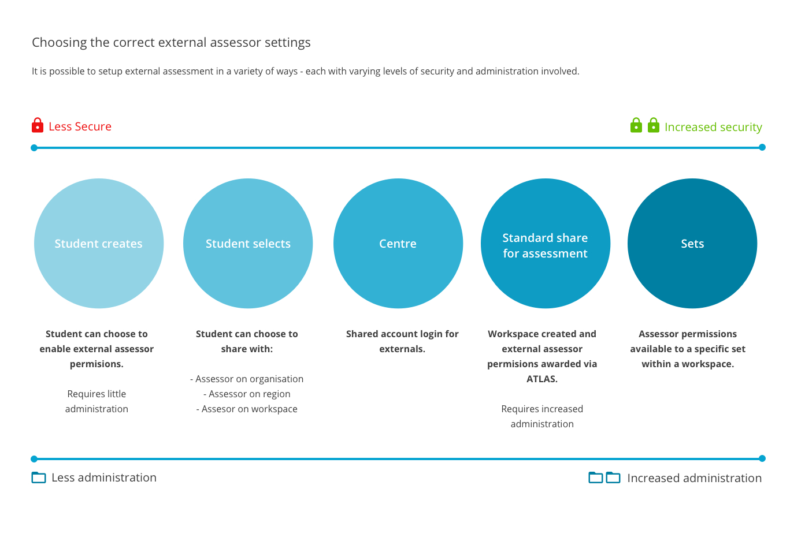
This feature may be used in cases where either there are several known assessors but these assessors have not been allocated to particular students in advance of the student being assessed, or if the assessors have not yet been identified to your organisation.
This tipsheet is aimed at Lead Tutors as a guide in getting started. You are invited to use the content from this tipsheet to develop instructions for your students and for your external assessors that are contextualised to your workflow. An editable version of this document can be accessed on the PebblePad Community site.
Note: this feature is not available for assignments with assessor-initiated submissions.

For lead tutors / workspace creators
Enabling the feature in ATLAS
From within a workspace click on the Management Tab and choose Settings. The option to allow users to select an external assessor is located at the very bottom of this screen.

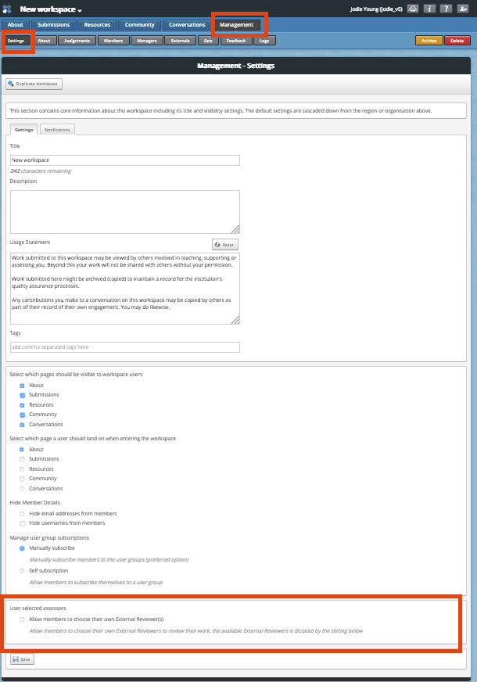

Once you have selected this option, you will be prompted to make some choices:
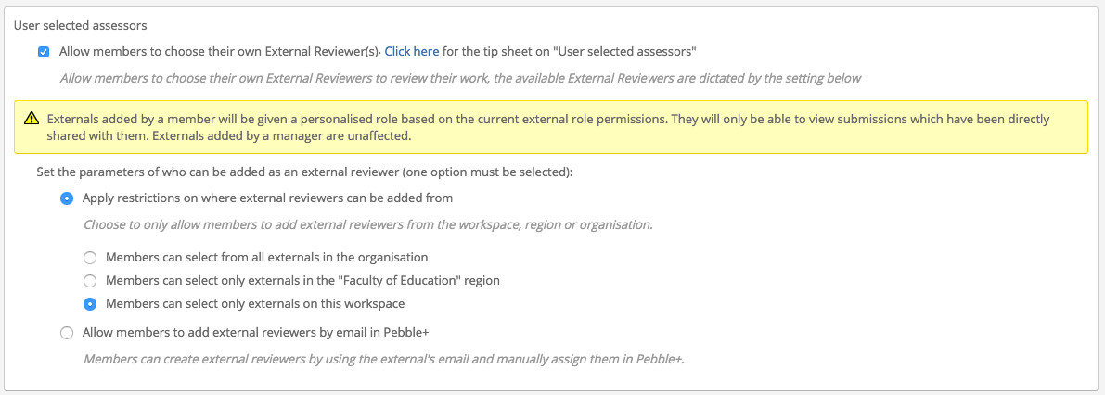

If you wish students to only be able to choose from external assessors that are already in the system, then choose the first option Apply restrictions on where external reviewers can be added from (this is the preselected option). You can allow members to choose externals across the entire organisation, or restricted to region or workspace.
Sometimes it is not possible to know in advance who the available assessors from an organisation will be. In this case, you can select the option to Allow members to add external reviewers by email in Pebble+.
Be sure to check the permissions for Externals in ATLAS. Any Externals created by students will by default have the same permissions as those set for Externals added by managers, except for the ability to view submissions on the workspace. They can only view submissions via the landing page when they log in or by clicking on the link to the asset in the email notification.

Setting up the assignment
The smoothest workflow for this feature is to have a resource that is set to auto-submit to an assignment. Prior to the date of assessment, students will need to save the asset which will then be shared to the workspace. The students will subsequently choose their assessors (e.g. once they arrive on placement). If you have set a resource to auto-submit to the assignment and you are only using auto-submission, in your assignment settings deselect the option to Allow submissions from Pebble+. This will ensure students do not try to manually share other assets for assessment.

Note: You do not have to use auto-submit resources for students to be able to choose their assessor. However, if the resource is not set to auto-submit the students will need to manually share their asset for assessment via the I want to… share button before the option to share with an external assessor is made available to them. In most cases we anticipate the first share to the workspace will occur quite some time prior to their needing to share with an assessor.

For students
Sharing to the workspace for assessment
Go to your Resources Store in Pebble+ and find the resource that has been shared with you from the workspace. The resource should be set to auto-submit your asset directly back to the workspace once you have saved.

On placement – choosing your assessor
Go to your asset store and select the asset you want the assessor to view, by clicking on the icon to the left of the title.
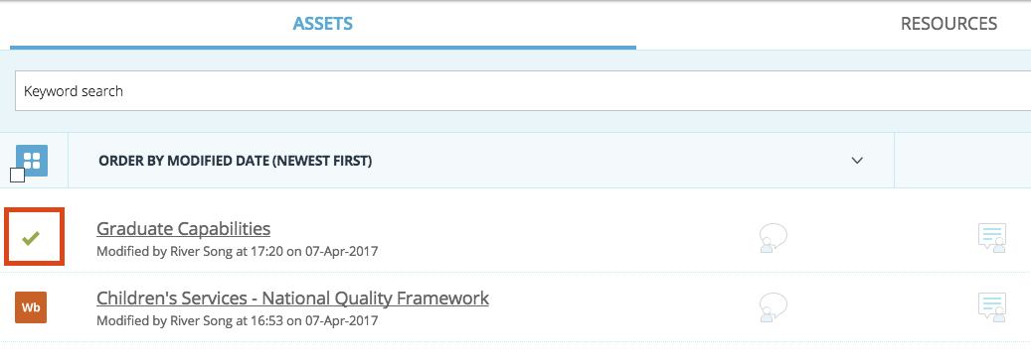

Now click on the blue I want to… button at the bottom right of the screen and choose Share.

You will see the following panel:

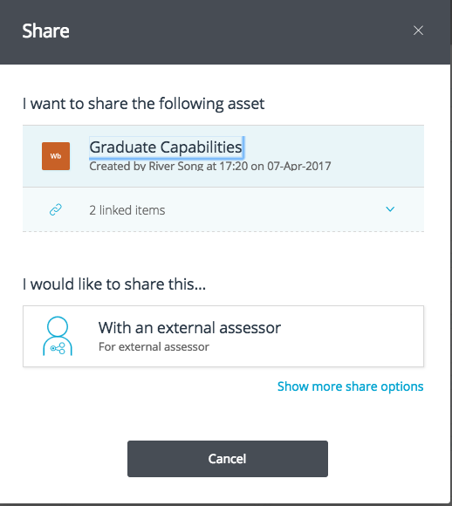
Click on With an external assessor.
Type in the email address of your external assessor and click on the Search icon. If your assessor is already in the system, you will be able to click Share asset once the external assessor has been found.
If your external assessor is not in the system you will see the message “No external user was found with that email address” and the option to Add a new external. Complete the details and click Create. Your assessor will receive an email with details of how to view and assess your work.
Note: If you do not see the Add a new external option, it will be because your university / organisation has not enabled it. In this case you will need to find an assessor who is already in the system or contact your tutor/lecturer.

Once you have shared your work for assessment, you can view your shares in your Asset store at any time by clicking on the Shared for assessment icon or the info icon to the right of the screen. Scroll down to the Shared for assessment section and click on the Show external assessors link to see who your asset has been shared with.

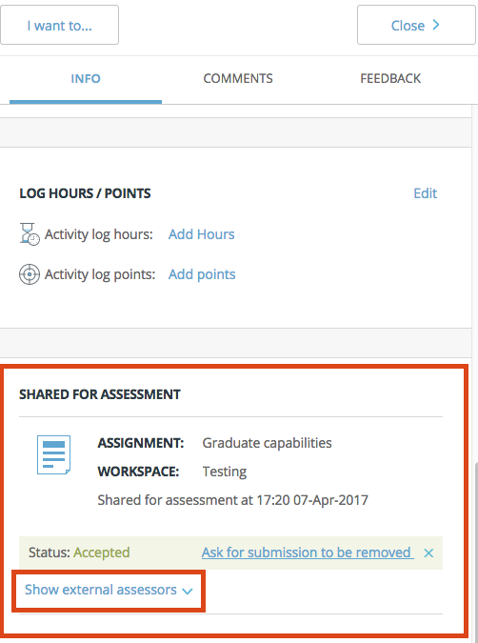

For external assessors
PebblePad now allows Externals to be added to a workspace in two ways – either by a workspace manager, or by the learner. If you have previously viewed submissions on a workspace for assessment, you may notice a difference in how you can access learner assets when a student has selected you as an assessor.

Logging in to view assets shared for assessment
If you have not had access to PebblePad before, once the student has added you as an assessor, you will receive an email containing your login details – username (which will be your email address) and password. Clicking on the link in this email will allow you to see all shared assets and workspaces on a screen similar to this:

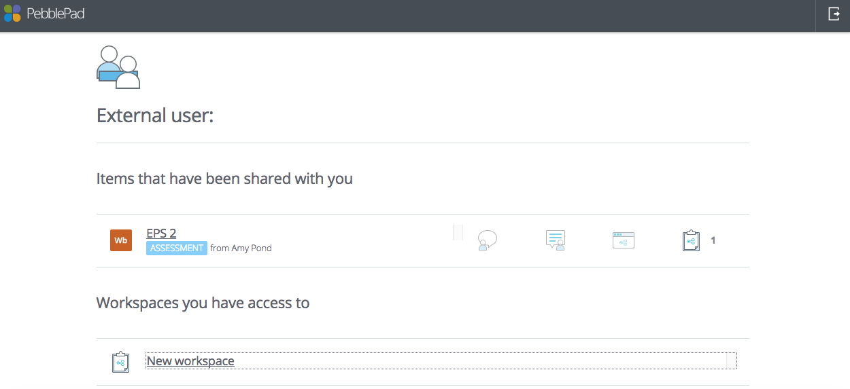

If you have previously accessed PebblePad as an external assessor, simply log in as usual and you will see the same screen.
Clicking on the item that has been shared with you will open the asset and allow you to view and provide feedback.

Workspaces
Clicking on a workspace title will allow you to see pages of the workspace made available by the workspace creator, such as the About page displaying course information, Submissions page which displays learner assets, Resources or Conversations. Your institutional contact will let you know if it is necessary for you to visit the workspace at all.
From the workspace, if you wish to return to the list of items that have been shared with you, you must use your browser back button.
Note: if you have previously viewed learner assets via the Submissions button on a workspace, this option may not be available if the learner has shared their asset with you directly. You will need to access the asset either from the landing screen or email link (see below).

Viewing an asset directly from an email notification
When a learner adds you as their external assessor, you will also receive an email notifying you that the student has shared an asset with you for assessment, with the subject Asset share (With external assessor permissions). You can also access the asset by clicking on the link in this email. This will prompt you to login and you will be taken directly to the asset.

Note: This method will only allow you to view a specific asset, and not the list of assets from any other students.

